**<Autumn 2018>**

**계산영상시스템**

**Assignment #2**

|  |
| --- |
| **심현정 교수님**  **글로벌융합공학부**  **2016314428 김진혁** |

**LINEARIZE RENDERED IMAGES**

**Code**

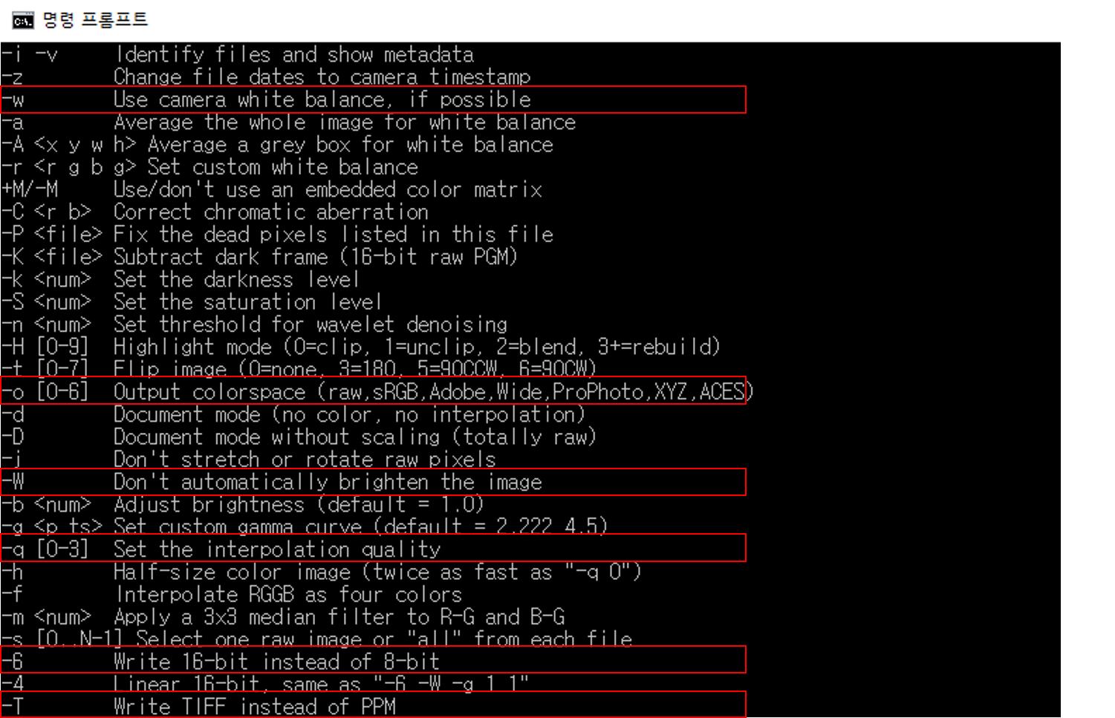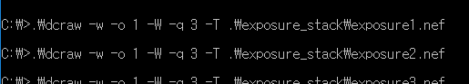

DCraw 프로그램을 다운받아 def 파일을 tiff 파일로 변환하였다. 사용한 버전은 9.27이며, 사용한 명령어는 위 사진에 표시한 6개이다.



문제에서 주어진 공식을 사용하여 의 형태로 정리한 후, least-square를 취하며 최적화하면 값을 얻을 수 있다.

|  |
| --- |
| % Linearize Rendered images  image = {};  dir = 'exposure_stack\\exposure';  for i = 1:16  image{end+1} = imread(strcat(dir, int2str(i), '.tiff'));  image{end} = im2uint8(imresize(image{end}, 0.125));  end  image_jpg = {};  for i = 1:16  image_jpg{end+1} = imread(strcat(dir, int2str(i), '.jpg'));  image_jpg{end} = im2uint8(imresize(image_jpg{end}, 0.125));  end    for c = 1:3  sample = zeros(32000, 1, 'uint8');  for i = 0:3999  x = randi(500); y = randi(750);  for j = 1:16  sample(i*16 + j) = image_jpg{j}(x, y, c);  end  end    image_g = zeros(32256, 256);  b = zeros(30255, 1);  for i = 0:1999  for j = 1:15  image_g((i*16 + j), sample((i*16 + j)) + 1) = 1;  b(i*15 + j) = log(2) * getw(sample(i*16 + j + 1));  end  image_g((i*16 + 16), sample((i*16 + 16)) + 1) = 1;  end    for i = i:256  image_g(32000+i, i) = 1;  end  b(30255) = log(255);    diff = zeros(30255, 32256);  for i = 0:1999  for j = 1:15  diff(i*15 + j, i*16 + j) = -b(i*15 + j);  diff(i*15 + j, i*16 + j+1) = b(i*15 + j);  end  end  for i = 1:254  diff(30000+i, 32000+i) = 1;  diff(30000+i, 32000+i+1) = -2;  diff(30000+i, 32000+i+2) = 1;  end  diff(30255, 32256) = 1;    A = diff*image_g;  g(c, :) = A \ b;  end |

**Result**

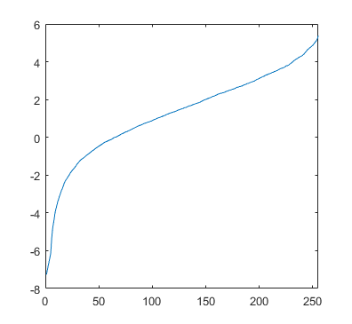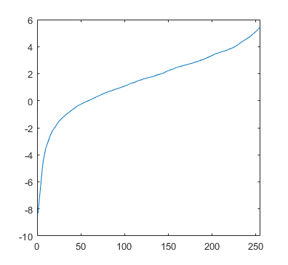



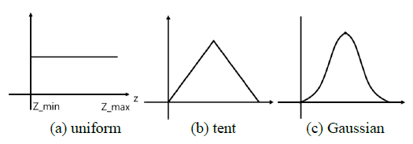

**MERGE EXPOSURE STACK INTO HDR IMAGE**

**Code**

|  |
| --- |
| for c = 1:3  merge = 0;  for i = 1:500  for j = 1:750  weight = 0;  v = 0;  for f = 1:16  v = v+getw(image{f}(i, j, c))*double(image{f}(i, j, c))*2^(-f);  %if ( image{f}(i, j, c) > 0 )  % v = v+getw(image{f}(i, j, c))*(log(double(image{f}(i, j, c)))-log(2)*f);  %end  %v = v+getw(image_jpg{f}(i, j, c))*exp(g(c, image_jpg{f}(i, j, c)+1));  %v = v+getw(image_jpg{f}(i, j, c))* (g(c, image_jpg{f}(i, j, c)+1)-log(2)*f);  weight = weight+getw(image_jpg{f}(i, j, c));  end  if weight ~= 0  v = v/weight;  end    %v = exp(v);    image__(i, j, c) = v;  if ( merge < v )  merge = v;  end  end  end  image__(:, :, c) = image__(:, :, c) ./ m;  end |

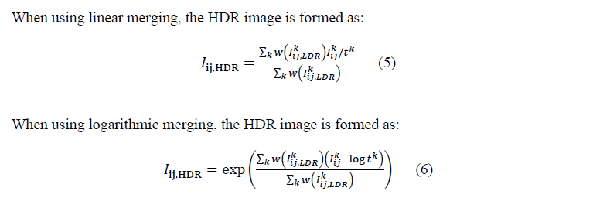

문제에서 주어진 공식을 사용하여 linear merging과 logarithmic merging을 수행하였다. 각 주석의 line들은 raw/render 및 linear/logarithmic에 맞게 사용되었다.

**Result**

|  |  |  |
| --- | --- | --- |
| **UNIFORM** | LINEAR | LOGARITHMIC |
| RAW |  |  |
| RENDERED |  |  |

|  |  |  |
| --- | --- | --- |
| **GAUSSIAN** | LINEAR | LOGARITHMIC |
| RAW |  |  |
| RENDERED |  |  |

**EVALUATION**

**Code**

|  |
| --- |
| image_eval = rgb2xyz(image__, 'ColorSpace', 'srgb');  y_ = zeros(6, 1);    for f = 1:6  for i = fp(f, 1) - 3 : fp(f, 1) + 3  for j = fp(f, 2) - 3 : fp(f, 2) + 3  y_(f) = y_(f) + image_eval(j, i, 2);  end  end  y_(f) = log(y_(f) / 49);  end    err = 0;    for f = 2:5  err = err + ((y_(1) + (y_(6) - y_(1)) * (f-1) / 5) - y_(f)) ^ 2;  end |

위 문제에서 수행한 8장의 HDR image에 대한 least-square error를 계산하였다.

**Result**

|  |  |  |
| --- | --- | --- |
| **UNIFORM** | LINEAR | LOGARITHMIC |
| RAW | 0.03 | 0.0188 |
| RENDERED | 0.0498 | 0.0067 |

|  |  |  |
| --- | --- | --- |
| **GAUSSIAN** | LINEAR | LOGARITHMIC |
| RAW | 0.1347 | 0.0326 |
| RENDERED | 0.0549 | 0.0511 |

**PHOTOGRAPHIC TONEMAPPING**

**Code**

|  |
| --- |
| image_hdr = hdrread('tonemapping.hdr');    K = 0.5; B = 0.95; image_tone = zeros(500, 750, 3);    for c = 1:3  var = exp(1/(500*750) * sum(log(image_hdr(:, :, c) + 1e-15)));  var2 = image_hdr(:, :, c) * K / var;  var_white = B * max(var2(:));  tone = var2 .* (var2./(var_white^2) + 1) ./ (var2+1);  image_tone(:, :, c) = tone(:, :);  end    imwrite(image_tone, strcat('RGB_',int2str(K),'_',int2str(B),'.png'));    image_hdr_ = rgb2xyz(image_hdr, 'ColorSpace', 'srgb');  hdr = zeros(500, 750, 3);  hdr(:, :, 1) = image_hdr_(:, : ,1) ./ (image_hdr_(:, : ,1) + image_hdr_(:, : ,2) + image_hdr_(:, : ,3));  hdr(:, :, 2) = image_hdr_(:, : ,2) ./ (image_hdr_(:, : ,1) + image_hdr_(:, : ,2) + image_hdr_(:, : ,3));  hdr(:, :, 3) = image_hdr_(:, : ,2);    var = exp(1/(500*750) * sum(log(image_hdr(:, :, c) + 1e-15)));  var2 = image_hdr(:, :, c) * K / var;  var_white = B * max(var2(:));  tone = var2 .* (var2./(var_white^2) + 1) ./ (var2+1);    image_tone(:, :, 1) = tone(:, :).*hdr(:, :, 1)./hdr(:, :, 2);  image_tone(:, :, 2) = tone(:, :);  image_tone(:, :, 3) = tone(:, :).*(1-hdr(:, :, 1)-hdr(:, :, 2))./hdr(:, :, 2);    image_tone = xyz2rgb(image_tone);  imwrite(image_tone, strcat('Luminance_',int2str(K),'_',int2str(B),'.png')); |

문제에서 주어진 힌트대로 K=0.15, B=0.95에서 시작하여 최적의 값을 찾아나갔다. 우선, K 값을 먼저 찾고, 그 다음 B 값을 찾는 식으로 진행하였다. 진행한 결과, K=0.35, B=0.1에서 최적의 결과를 얻을 수 있었다.

**Result**

|  |  |  |
| --- | --- | --- |
|  | RGB | Luminance |
| K=0.35  B=0.95 |  |  |
| K=0.35  B=0.1 |  |  |

**TONEMAPPING USING BILATERAL FILTERING**

**Code**

|  |
| --- |
| image_hdr = hdrread('tonemapping_.hdr');    S=0.3; W=1.; sig=[5.,1.0]; image_tone = zeros(500, 750, 3);    for c = 1:3  image_L = log(image_hdr(:, :, c));  image_B = bfilter2(image_L, W, sig);  image_D = image_L-image_B;  image_B = (image_B-max(image_B(:))) .* S;  image_DB = exp(image_D+image_B);  image_tone(:, :, c) = image_DB(:, :);  end    imwrite(image_tone, strcat('RGB_',int2str(S),'_',int2str(W),'_',int2str(sig),'.png'));    image_hdr_ = rgb2xyz(image_hdr, 'ColorSpace', 'srgb');  hdr = zeros(500, 750, 3);  hdr(:, :, 1) = image_hdr_(:, : ,1) ./ (image_hdr_(:, : ,1) + image_hdr_(:, : ,2) + image_hdr_(:, : ,3));  hdr(:, :, 2) = image_hdr_(:, : ,2) ./ (image_hdr_(:, : ,1) + image_hdr_(:, : ,2) + image_hdr_(:, : ,3));  hdr(:, :, 3) = image_hdr_(:, : ,2);    image_L = log(hdr(:, :, 3));  image_B = bfilter2(image_L, W, sig);  image_D = image_L-image_B;  image_B = (image_B - max(image_B(:))) .* S;  image_DB = exp(image_D + image_B);  image_tone(:, :, 1) = image_DB(:, :) .* hdr(:, :, 1) ./ hdr(:, :, 2);  image_tone(:, :, 2) = image_DB(:, :);  image_tone(:, :, 3) = image_DB(:, :) .* (1 - hdr(:, :, 1) - hdr(:, :, 2)) ./ hdr(:, :, 2);    image_tone = xyz2rgb(image_tone);  imwrite(image_tone, strcat('Luminance_',int2str(S),'_',int2str(W),'_',int2str(sig),'.png')); |

위 문제와 마찬가지 방법으로 W, S, σ 값을 변화시키며 최적의 값을 찾아나갔다. 최적의 값으로는 W=5, S=0.2, σ[5, 1.0]을 얻어내었다.

**Result**

|  |  |  |
| --- | --- | --- |
| **W=5** | RGB | Luminance |
| S=0.5 |  |  |
| S=0.2 |  |  |

|  |  |  |
| --- | --- | --- |
|  | W=1 | W=10 |
| **S=0.2** |  |  |

|  |  |  |
| --- | --- | --- |
|  | σ[1, 1.0] | σ[5, 1.0] |
| **S=0.2 W=5** |  |  |